**Project – Fruit Catcher Game**

## Problem Statement

Catch falling fruits while avoiding bombs using Pygame(). Score points by catching fruits, but lose points for bombs. The game has multiple levels with increasing difficulty. Follow the specifications to design and develop the game.

## Flowchart





## 

## 

## 

## 

## 

## 

## 

## 

## 

## 

## 

## 

## 

## 

## 

## 

## 

## 

## 





## 

## 

## 

## 

## 

## 

## 

## 

## 

## 

## 

## 

## 

## 

## 

## 

## 

## 

## 

## 

## 

## 

## 

## 

## 

## 

## 

## 

## 

## 

## 

## 

## 

## 

## 

## 

## 

## 

## 

## 

## 

## 

## 

## 

## 

## 

## 

## 

## 

## 

## 

## 

## 

## 

## 

## 

## 

## 

## 

## 

## 

## 

## 

## 

## 

## 

## 

## 

## 

## 

## 

## 

## 

## 

## 

## 

## 

## 

## 

## 

## 

## 

## 

## 

## 

## Algorithm

1. import modules pygame,sys,random
2. initialize global variables
   1. FPS=60
   2. game_start_time=0
   3. lvl2_start_time=0
   4. scorez=''
   5. player_speed = 10
   6. fall_speed = 2
   7. spawn_rate = 2
   8. seconds = 0
   9. last_apple_time = 0
   10. bckgrnd = pygame.image.load('start-title.png')
   11. cur_fruit = ""
   12. l1b = pygame.image.load('l1_back.png')
   13. l2b = pygame.image.load('l2_back.png')
   14. lvlintr = pygame.image.load('lvl1.png')
   15. level_one_score = 0
   16. level_two_score = 0
   17. high_l1 = 0
   18. high_l2 = 0
   19. apfrt = pygame.image.load("apples.png")
   20. bafrt = pygame.image.load("banana.png")
   21. stfrt = pygame.image.load("strawberry.png")
   22. bomb=pygame.image.load("bomb.png")
   23. hud_font = pygame.font.Font('pixelify.ttf', 40)
3. set the standard template
   1. pygame.init()
   2. pygame.mixer.init()
   3. SCREEN_WIDTH=1000
   4. SCREEN_HEIGHT=650
   5. screen = pygame.display.set_mode((1000, 650))
   6. pygame.display.set_caption("Fruit Catcher!")
   7. clock = pygame.time.Clock()
   8. start_tick = pygame.time.get_ticks()
4. set default state by defining gameState as start
5. set the basket’s starting position
6. establish locations of the fruit
7. create main game loop
8. make a way to quit the game without finishing it using events
9. check gameState next
10. if gameState is ‘start’
    1. call startscreen()
    2. startscreen sets the background of start screen
    3. creates a start button in a way where if mouse is hovered over it the colour changes
    4. it makes use of button1() and mouse1()
    5. if we click on start change_to_l1() is called
       1. change_to_l1 starts the timer, starts the music and creates the fruit list
       2. it then sets gameState as level 1
11. as gameState is level 1 call level_one()
    1. set the background
    2. display timer and score
    3. display ‘catch only’ text
    4. if timer runs out, call change_to_inter, music plays
    5. calls player_control()
       1. loads basket image
       2. makes the image move by 10 pixels on the direction the user wants
       3. doesn’t let basket leave the boundaries
       4. also establishes collide system that increases or decreases points according to the rules
    6. calls fruit_generator()
       1. starts a timer of its own
       2. spawns in images of fruits at every spawn time
       3. makes the image drop
       4. removes it if it exceeds the height
12. change_to_inter()
    1. music stops
    2. sets state as inter
13. gameState is inter, intermediate() is called
    1. display intermediate background
    2. displays score of level 1
    3. ‘Press ENTER to for next level’ is printed at the bottom
    4. if enter or return is pressed call change_to_l2()
14. change_to_l2()
    1. starts timer
    2. increases spawn rate
    3. increases fall speed
    4. starts level 2 music
    5. starts timer
    6. sets state as level 2
15. as gameState is level 2, level_two() is called
    1. level 2 background is set
    2. catch fruit is specified
    3. if timer runs out change_to_end() is called
16. change_to_end()
    1. music stops
    2. state is set to end
17. as state is set as end, endscreen() is called
    1. displays end screen background
    2. creates a quit button that exits the game if pressed
    3. calls addscore()
       1. creates a file if no data has been saved prior and saves your current score
       2. if the file has data it compares each of the scores(level one, level two, total) with the saved values
       3. it updates to the higher score
    4. finally your current scores is displayed along with the highest scores attained in each level and totally

## Test Cases

Start screen

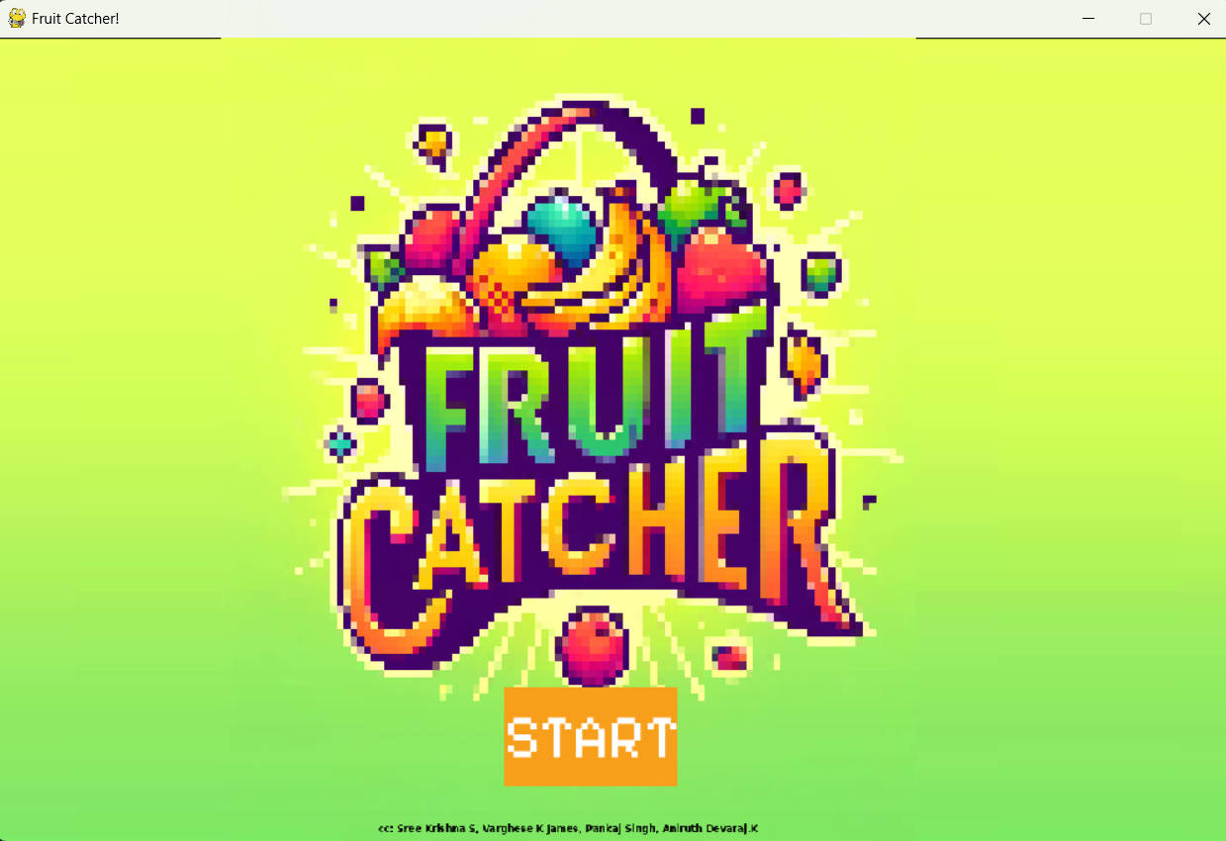

Level one screen

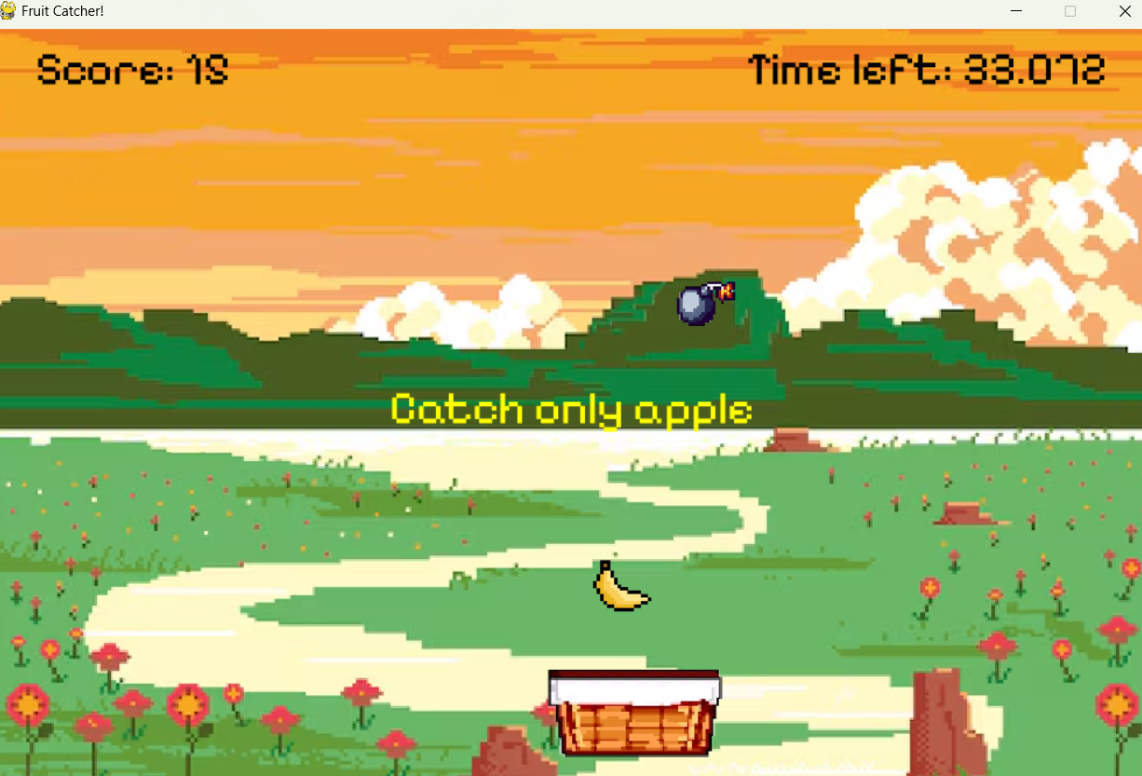

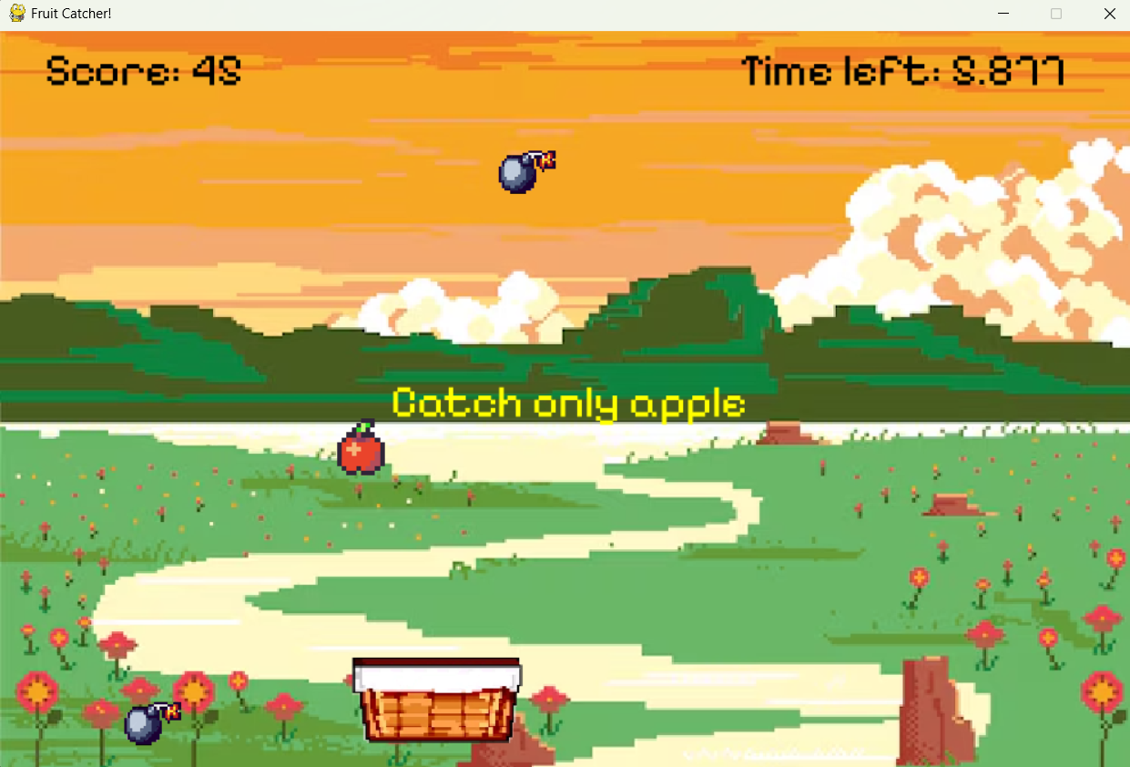

Level change Screen

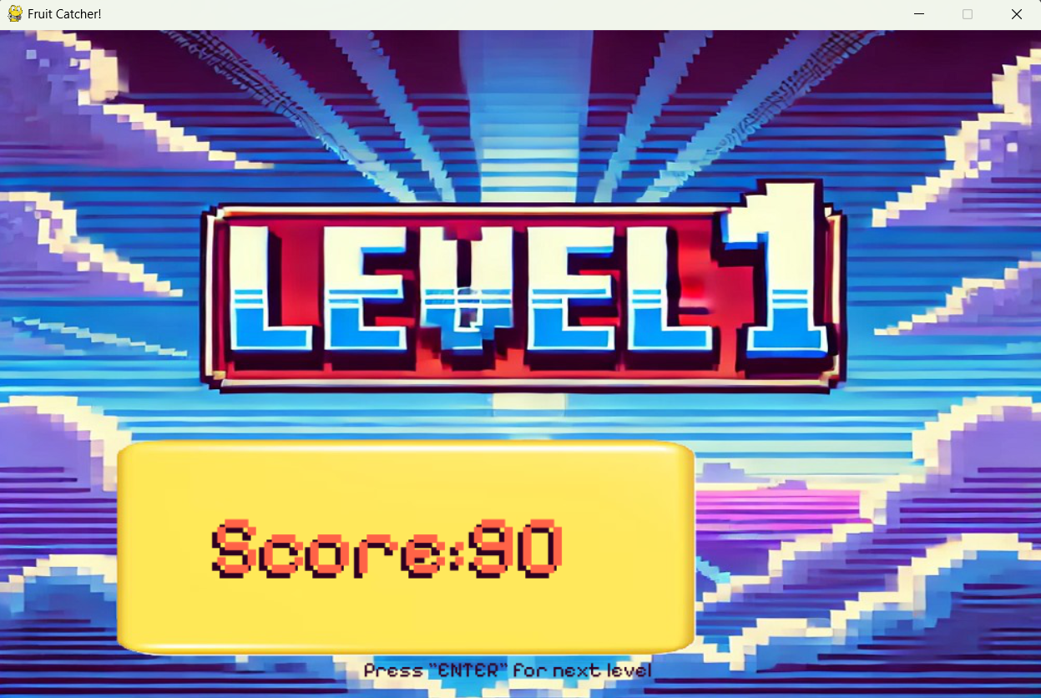

level 2 screen

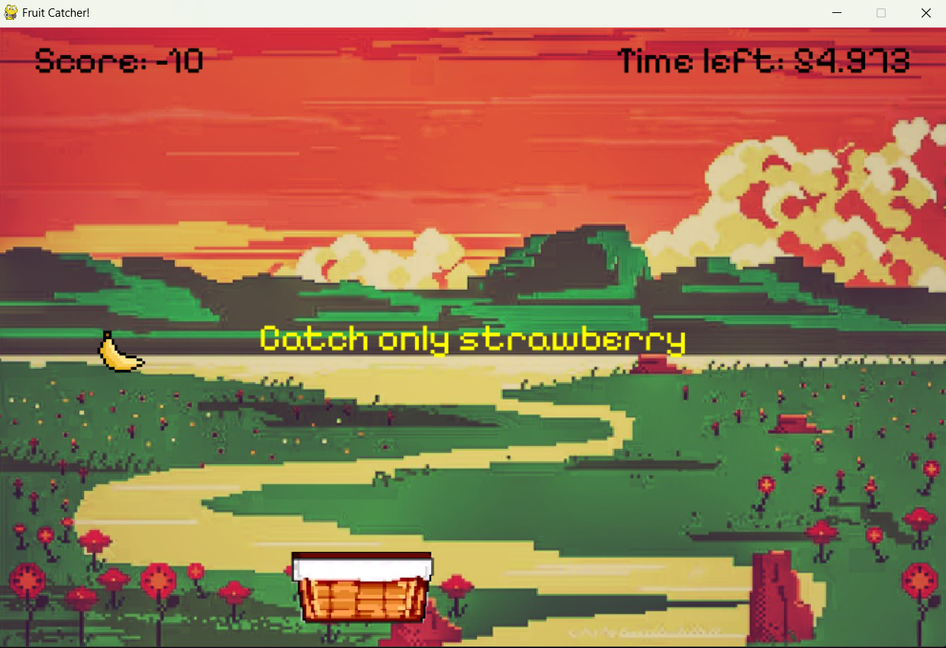

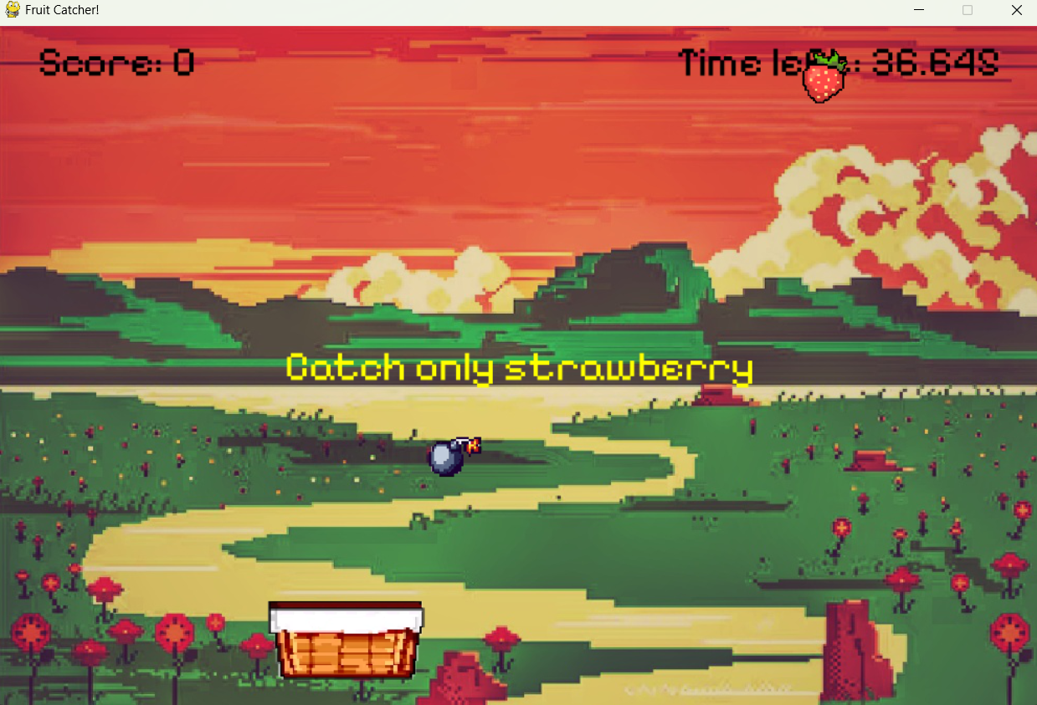

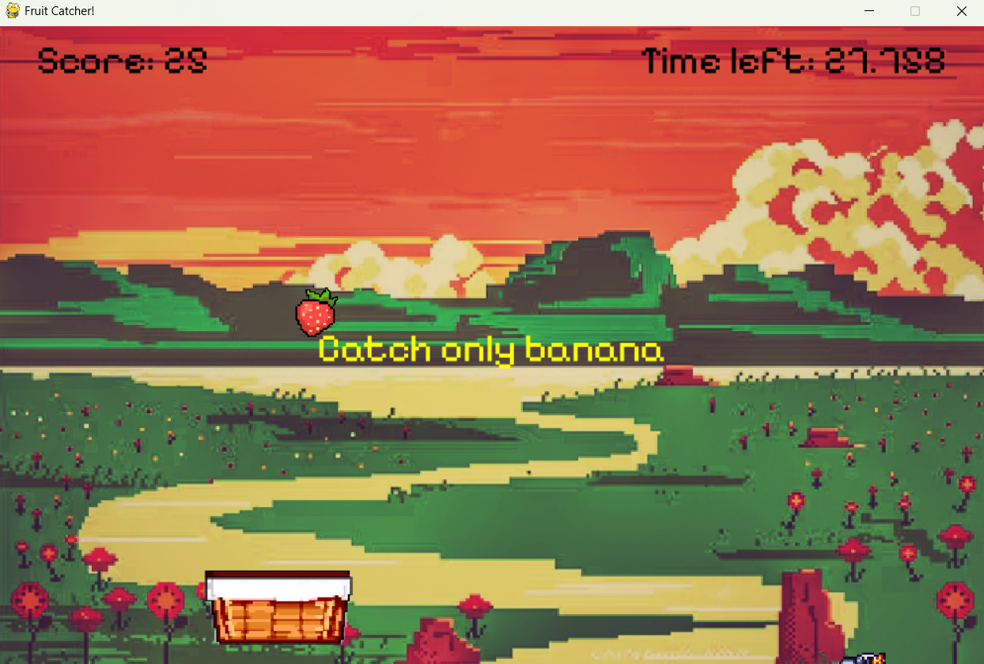

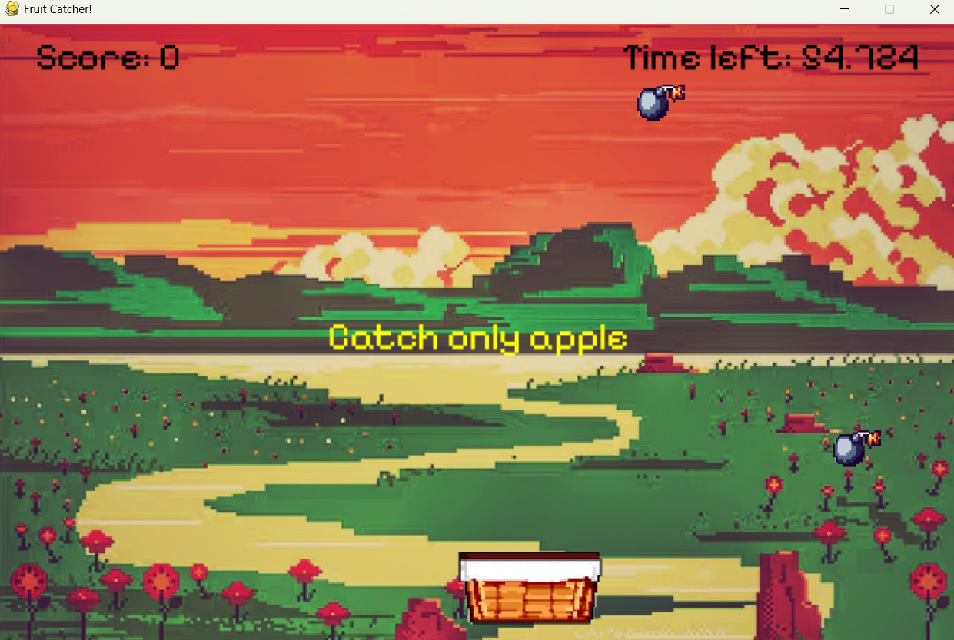

End screen

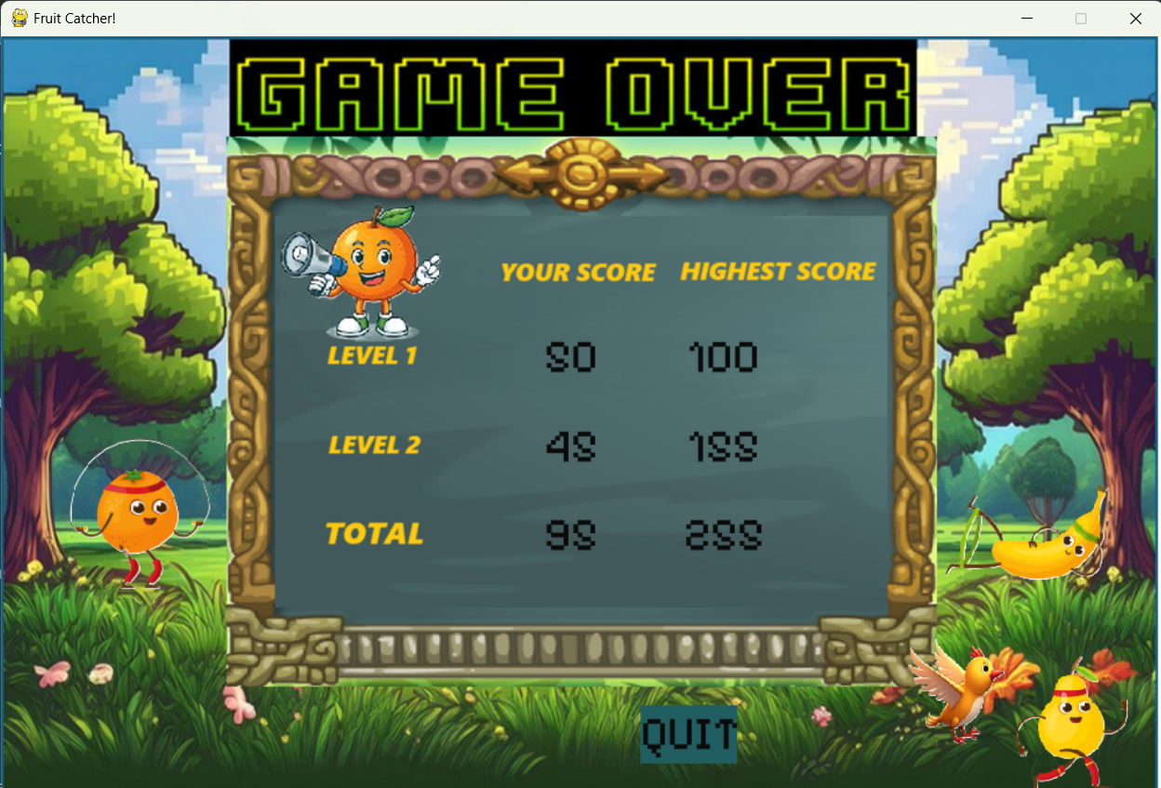

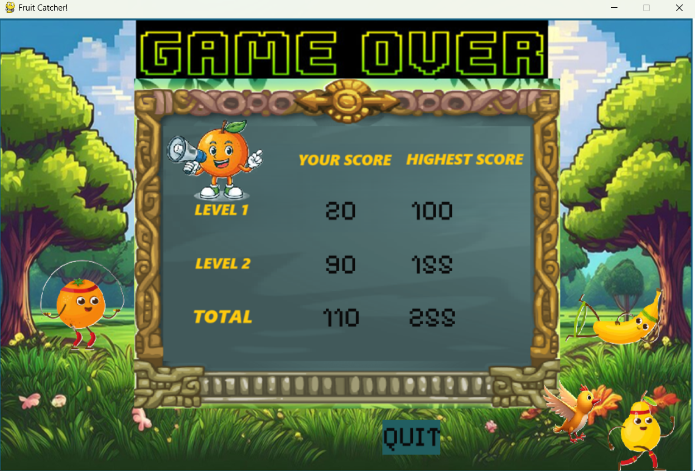

| Source Code **import** pygame, sys, random  *### Constants ###* FPS = 60 game_start_time=0 lvl2_start_time=0 SCREEN_WIDTH=1000 SCREEN_HEIGHT=650  pygame.init() pygame.mixer.init() screen = pygame.display.set_mode((SCREEN_WIDTH, SCREEN_HEIGHT)) pygame.display.set_caption("Fruit Catcher!") clock = pygame.time.Clock() start_tick = pygame.time.get_ticks()  *### GLOBAL VARIABLES ###* scorez='' player_speed = 10 fall_speed = 2 spawn_rate = 2  seconds = 0 last_apple_time = 0 cur_fruit = "" level_one_score = 0 level_two_score = 0 high_l1 = 0 high_l2 = 0  gameState = 'start' player_pos = pygame.Vector2((screen.get_width() / 2)-100, (screen.get_height() - 100)) fruit_dict = [{'name': "apple", 'loc': [500,0], 'rect': **None**}]  bckgrnd = pygame.image.load('start-title.png') l1b = pygame.image.load('l1_back.png') l2b = pygame.image.load('l2_back.png') lvlintr = pygame.image.load('lvl1.png') apfrt = pygame.image.load("apples.png") bafrt = pygame.image.load("banana.png") stfrt = pygame.image.load("strawberry.png") bomb = pygame.image.load("bomb.png") hud_font = pygame.font.Font('pixelify.ttf', 40) sfont = pygame.font.Font('pixelify.ttf',50)  **def** **set_state**(state):  **global** gameState  gameState = state  **def** **backimg**(img):  size = pygame.transform.scale(img,(1000,650))  screen.blit(size,(0,0))  *### PLAYER SPECIFIC FUNCTIONS ###*  **def** **score_change**(change):  **global** level_one_score, level_two_score  **if** gameState == 'level 1':  level_one_score += change  **if** level_one_score >= 100:  change_to_inter()  **elif** gameState == 'level 2':  level_two_score += change  **if** level_two_score >= 150:  change_to_end()  **def** **player_control**():   **global** player_pos   basket = pygame.image.load("new_basket.png")  basketrect = basket.get_rect()  basketrect.x = player_pos.x  basketrect.y = player_pos.y   keys = pygame.key.get_pressed()   **if** keys[pygame.K_LEFT] **or** keys[pygame.K_a]:  **if** **not** player_pos.x < 0:  player_pos.x -= player_speed  **if** keys[ pygame.K_RIGHT] **or** keys[pygame.K_d]:  **if** **not** player_pos.x > 850:  player_pos.x += player_speed   frtrectlist = []  **for** frt **in** fruit_dict:  frtrectlist.append(frt['rect'])  col_i = basketrect.collidelist(frtrectlist)  **if** col_i != -1:  col_fruit = fruit_dict[col_i]['name']  fruit_dict.pop(col_i)   **if** cur_fruit == col_fruit:  sound1=pygame.mixer.Sound("pling.mp3")  sound1.play(loops=0, maxtime=0, fade_ms=0)  score_change(10)  **elif** col_fruit == 'bomb':  sound2=pygame.mixer.Sound("small-explosion-129477.mp3")  sound2.play(loops=0, maxtime=0, fade_ms=0)  **if** gameState == 'level 2':  score_change(-10)  **else**:  score_change(-5)  **else**:  score_change(5)   screen.blit(basket, basketrect)  *### FRUIT SPECIFIC FUNCTIONS ###*  **def** **fruit_generator**():  **global** fruit_dict, last_apple_time   seconds = (pygame.time.get_ticks()-start_tick)/1000   **if** seconds - last_apple_time > spawn_rate:  fruitlist = ["apple","banana","strawberry", "bomb", "bomb", "bomb"]  a = random.randint(0,5)  last_apple_time = seconds  entry = {'name': fruitlist[a], 'loc': [random.randint(25,975), 0], 'rect': **None**}  fruit_dict.append(entry)    **for** fl **in** fruit_dict:  **if** fl['name'] == 'apple':  frt = apfrt  **elif** fl['name'] == 'banana':  frt = bafrt  **elif** fl['name'] == 'strawberry':  frt = stfrt  **elif** fl['name']=='bomb':  frt=bomb   frtrect = frt.get_rect()  fl['rect'] = frtrect  frtrect.x = fl['loc'][0]  frtrect.y = fl['loc'][1]   *## Update the falling for next round*  fl['loc'][1] = frtrect.y + fall_speed  **if** frtrect.y > 650:  fruit_dict.remove(fl)   screen.blit(frt, frtrect)  *### GAME STATES ###*  **def** **mouse1**():  m = pygame.mouse.get_pos()  **if** 410<m[0]<410+140 **and** 525<m[1]<525+80:  pygame.draw.rect(screen, (135, 232, 97), (410, 525, 140, 80))  button1()   **def** **button1**():  b=sfont.render('START',**True**,(255,255,255))  screen.blit(b,(410,535,100,50))  **def** **change_to_l1**():  **global** game_start_time, cur_fruit  pygame.mixer.music.load("music_lvl1.mp3")  pygame.mixer.music.play(loops=-1, start=0.0)  set_state('level 1')  fruitlist=["apple","banana","strawberry"]  a=random.randint(0,2)  cur_fruit = fruitlist[a]  game_start_time = pygame.time.get_ticks()  **def** **startScreen**():  **global** game_start_time, cur_fruit   screen.fill('blue')  backimg(bckgrnd)   pygame.draw.rect(screen,(247, 159, 27),(410,525,140,80))  button1()  mouse1()   moupos=pygame.mouse.get_pos()  moupres=pygame.mouse.get_pressed()[0]  is_hovered=(410<=moupos[0]<=410+140 **and** 525<=moupos[1]<=525+80)  **for** eve **in** pygame.event.get():  **if** eve.type == pygame.MOUSEBUTTONDOWN **and** is_hovered:  change_to_l1()  **def** **timer_disp**(l_start):  **global** hud_font   time_left = (60000+(l_start - start_tick)-pygame.time.get_ticks())/1000  time_text='Time left: '+str(time_left)  **if** time_left > 0:  timer=hud_font.render(time_text, **True**, (0,0,0))  screen.blit(timer,(650,10))  **return** time_left  **def** **score_disp**(l_score):  score='Score: ' + str(l_score)  text_image = hud_font.render(score, **True**, (0,0,0))   screen.blit(text_image, (40,10))   **def** **add_score**():  **global** high_l1, high_l2  **try**:  file = open('save.txt','r+')  scores = file.readline()  score_list = scores.split()    scorez = ""  **if** int(score_list[0]) < level_one_score:  scorez += str(level_one_score)+' '  high_l1 = level_one_score  **else**:  scorez += str(score_list[0])+' '  high_l1 = int(score_list[0])   **if** int(score_list[1]) < level_two_score:  scorez += str(level_two_score)+' '  high_l2 = level_two_score  **else**:  scorez += str(score_list[1])+' '  high_l2 = int(score_list[1])   high_total = high_l1 + high_l2  scorez += str(high_total)  file.seek(0)  file.write(scorez)  **except** FileNotFoundError:  file = open('save.txt', 'w+')  file.write(str(level_one_score)+' '+str(level_two_score)+' '+str(level_one_score+level_two_score))  *# Scene switchers*  **def** **change_to_inter**():  pygame.mixer.music.stop()  set_state('inter')  *# Level One Logic* **def** **level_one**():   backimg(l1b)   time_left = timer_disp(game_start_time)  score_disp(level_one_score)    catch = "Catch only " + cur_fruit   catch_text = hud_font.render(catch, **True**, (255,255,0))   catch_rect= catch_text.get_rect()  catch_rect.center = (1000// 2, 650// 2)  screen.blit(catch_text,catch_rect)   keys = pygame.key.get_pressed()   **if** time_left<=0:  change_to_inter()   **if** keys[pygame.K_SPACE]:  pygame.mixer.music.stop()  set_state('inter')   fruit_generator()  player_control()  **def** **change_to_l2**():  **global** lvl2_start_time, cur_fruit  **global** fall_speed, spawn_rate   pygame.mixer.music.load("music_lvl2.mp3")  pygame.mixer.music.play(loops=-1, start=0.0)   fall_speed = 6  spawn_rate = 1   set_state('level 2')  fruitlist=["apple","banana","strawberry"]  a = random.randint(0,2)  cur_fruit = fruitlist[a]  lvl2_start_time = pygame.time.get_ticks()  **def** **intermediate**():   screen.blit(lvlintr,(0,0))  intr_font = pygame.font.Font('pixelify.ttf', 80)  intr_scr = 'Score:' + str(level_one_score)  intr_disp = intr_font.render(intr_scr,**True**,(46,0,32))  intr_disp_shadow = intr_font.render(intr_scr,**True**,(255,99,71))  screen.blit(intr_disp,(200,450))  screen.blit(intr_disp_shadow, (205, 445))   intr_nxt='Press "ENTER" for next level'  intr_nfont = pygame.font.Font('pixelify.ttf', 20)  intr_btm = intr_nfont.render(intr_nxt,**True**,(46,0,32))  screen.blit(intr_btm,(350,600))  key=pygame.key.get_pressed()   **if** key[pygame.K_RETURN] **or** key[pygame.K_KP_ENTER]:  change_to_l2()  **def** **change_to_end**():  pygame.mixer.music.stop()  set_state('end')  **def** **level_two**():   backimg(l2b)  tl = timer_disp(lvl2_start_time)  score_disp(level_two_score)    catch2 = "Catch only " + cur_fruit  catch_text2 = hud_font.render(catch2,**True**,(255,255,0))   catch_rect2= catch_text2.get_rect()  catch_rect2.center = (1000// 2, 650// 2)  screen.blit(catch_text2,catch_rect2)   **if** tl<=0:  change_to_end()  player_control()  fruit_generator()  **def** **end_screen**():   add_score()   mpos=pygame.mouse.get_pos()  mpres=pygame.mouse.get_pressed()[0]  gamovr=pygame.image.load('final_background image.png')  gameover= gamovr.get_rect()  screen.fill('yellow')  screen.blit(gamovr,gameover)   qtext = hud_font.render('QUIT', **True**, (10,10,10))  pygame.draw.rect(screen,(33,94,97),(550,575,83,50))  screen.blit(qtext, (550,575))  quitrect = qtext.get_rect()  quitrect.topleft = (550, 575)   *#displaying score*  l1 = level_one_score  l2 = level_two_score  highl1 = high_l1  highl2 = high_l2  sumyour=l1+l2  sumhigh=highl1+highl2   l1dis=hud_font.render(str(l1), **True**, (10,10,10))  l2dis=hud_font.render(str(l2), **True**, (10,10,10))  highl1dis=hud_font.render(str(highl1), **True**, (10,10,10))  highl2dis=hud_font.render(str(highl2), **True**, (10,10,10))  sumyourdis=hud_font.render(str(sumyour), **True**, (10,10,10))  sumhighdis=hud_font.render(str(sumhigh), **True**, (10,10,10))   l1dis_rect= l1dis.get_rect()  l1dis_rect.center = (490,275)  screen.blit(l1dis,l1dis_rect)   l2dis_rect= l2dis.get_rect()  l2dis_rect.center = (490,352)  screen.blit(l2dis,l2dis_rect)   highl1dis_rect= highl1dis.get_rect()  highl1dis_rect.center = (621,275)  screen.blit(highl1dis,highl1dis_rect)   highl2dis_rect=highl2dis.get_rect()  highl2dis_rect.center = (621,352)  screen.blit(highl2dis,highl2dis_rect)   sumyourdisdis_rect= sumyourdis.get_rect()  sumyourdisdis_rect.center = (490,428)  screen.blit(sumyourdis,sumyourdisdis_rect)   sumhighdis_rect=sumhighdis.get_rect()  sumhighdis_rect.center = (621,428)  screen.blit(sumhighdis,sumhighdis_rect)   *### END GAME LOOP ###*  running = **True**  **while** running:  **for** event **in** pygame.event.get():  **if** event.type == pygame.QUIT:  pygame.quit()  sys.exit()  **elif** event.type == pygame.MOUSEBUTTONDOWN:  mouse_pos = pygame.mouse.get_pos()  **if** quitrect.collidepoint(mouse_pos):  pygame.quit()  sys.exit()   pygame.display.flip()   *### MAIN GAME LOOP ###* **while** **True**:  **for** event **in** pygame.event.get():  **if** event.type == pygame.QUIT:  pygame.quit()  sys.exit()   **if** gameState == 'start':  startScreen()  **elif** gameState == 'level 1':  level_one()  **elif** gameState == 'inter':  intermediate()  **elif** gameState == 'level 2':  level_two()  **elif** gameState == 'end':  end_screen()   pygame.display.flip()  clock.tick(FPS) |
| --- |